MACH4METAL

metalworking machinery
Transito 21
6909 DA BABBERICH Netherlands
Tel. +31 (0)316-247123
Fax: +31 (0)316-247956
info@mach4metal.com
www.mach4metal.com

Bank No : 66.52.13.883
IBAN : NL33 INGB 0665 2138 83
BIC : INGBNL2A

CNC ROUNDO 4 R-6-S Profile bender
- Make : ROUNDO Sweden
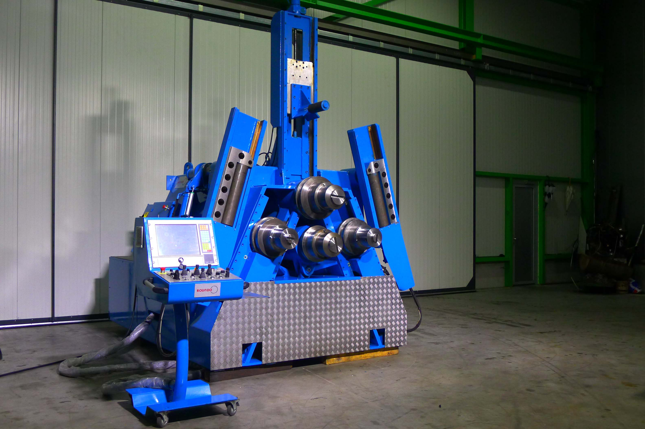
- Typ : 4 R - 6 - S
- Serial No. : 098528
- Age : 2009

- Ø Top roll shaft : 180
- Ø Side roll shaft : 150

- Ø Top roll : 400
- Ø Side roll : 320
- Max. section modulus : 90 cm³
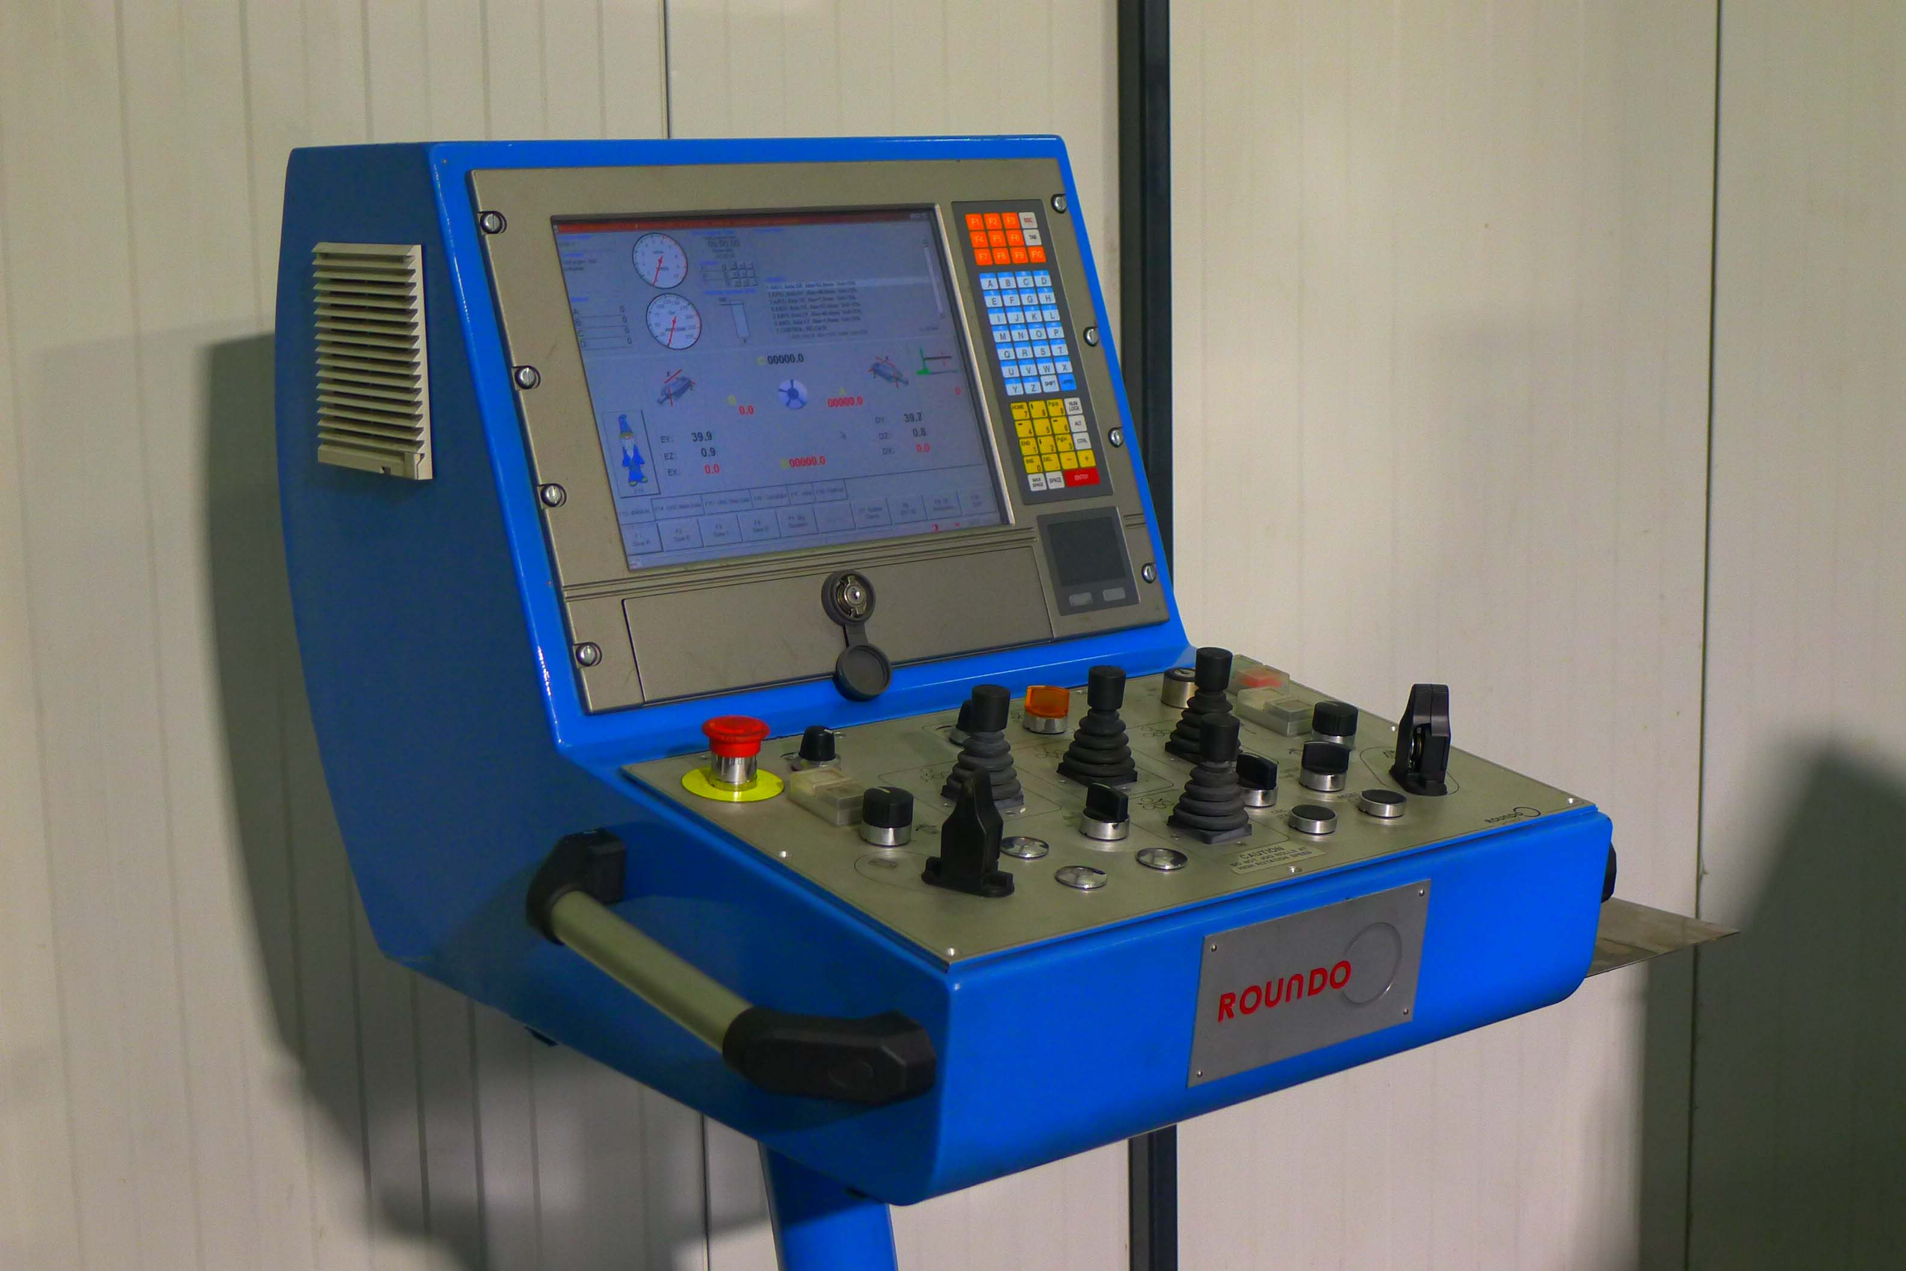
- Power : 15 kW
- Rolling speed : 0 – 7 M/min.

- Angle 140 x 140 x 15 Ø 1600
- Flatt 150 x 40 Ø 2000
- Tube 168 x 8 Ø 2500
- I Profile 300 IPE Ø 1100
- HEA profile 160 HEA Ø 900

- Dimensions
- Length : 3.390
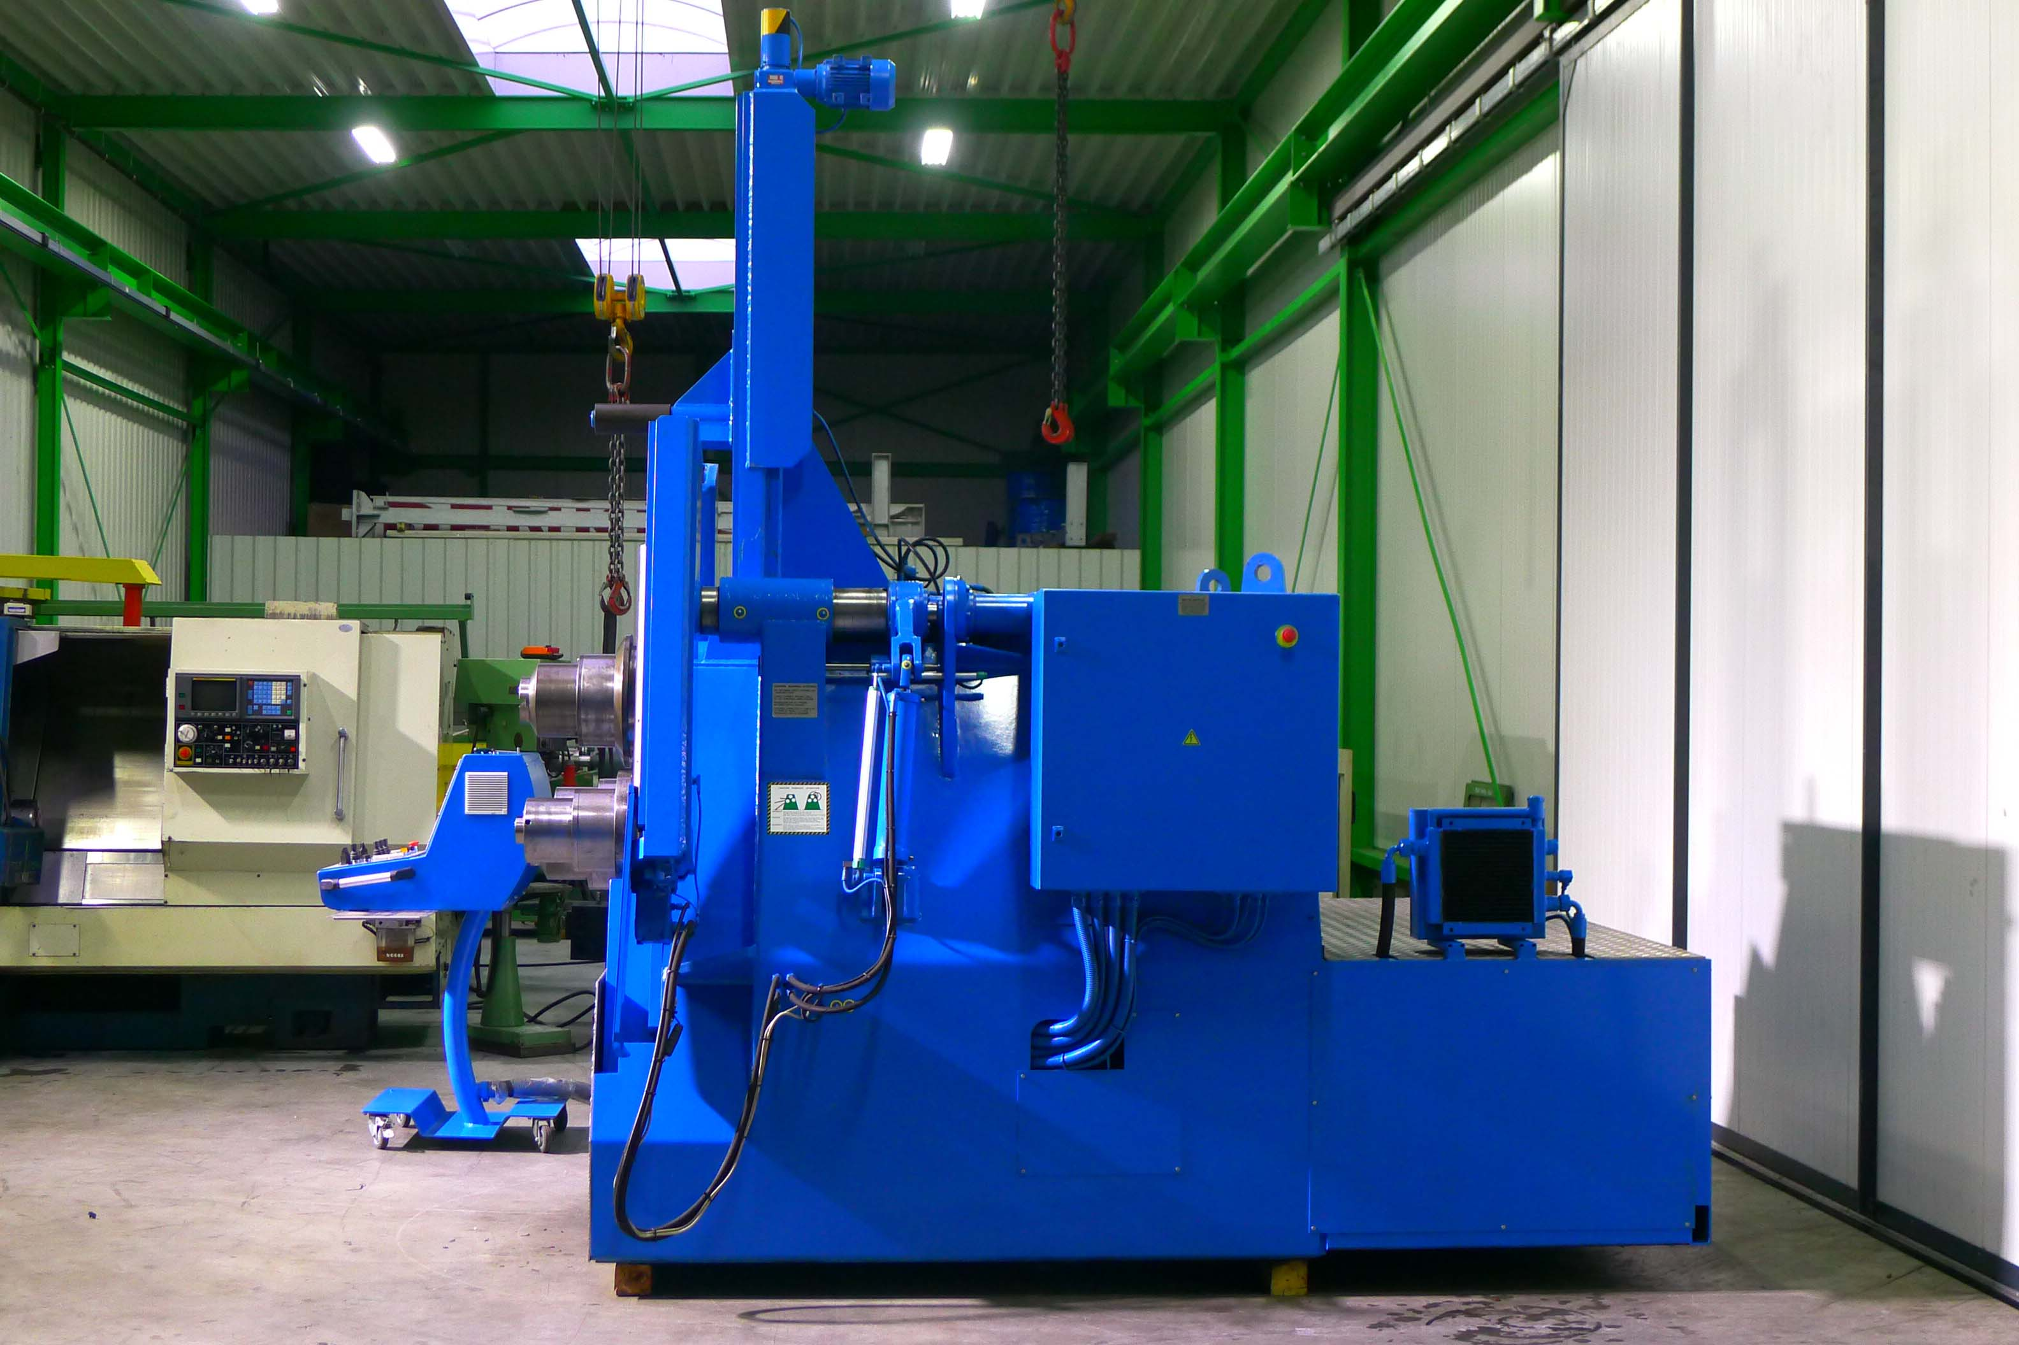
- Width : 3.415
- Height : 3.685 / 2.210 transport
- Weight : 8.000
v
- Roundo wCNC² CNC Control TFT
- Flying production
- Teach-in feature
- Graphical program simulation
- Drill-down function advanced program
- Bending wizards for easy Programming
- Interpolation function

Please Note: The above information has been obtained to the best of our ability and belief from, and from the manufacturers where possible. It is given in good faith, but its accuracy can not be guaranteed. Accordingly, it will not form a representation or constitute contractual terms. We advise you to check any vital details!

